| **Test Name** | | Modify/Update an Error – Changing Patient Id & Name | | | |
| --- | --- | --- | --- | --- | --- |
| **Use Case Tested:** | | Use Case 2 - Modify/Update an Error | | | |
| **Test Description:** | | User update an existing error  User searches errors to find error that requires correction.  User selects error record.  User is presented with the current data for the existing error in the Error Form.  User makes necessary changes to field/s  User submits form | | | |
| **Pre-conditions** | | Error must exist in the system | | | |
| **Post-conditions** | | The database is successfully updated with the new data for the error. | | | |
| **Notes:** | |  | | | |
| **Result (Pass/Fail/Warning/Incomplete)** | |  | | | |
|  | **TEST STEP** | | **EXPECTED TEST RESULTS** | P | F |
|  | User selects “Search Error” from the menu bar | | A list of errors in the database appears | X |  |
|  | User refines search by entering patient name/id in the search field | | List of errors for patient is returned | X |  |
|  | User selects error to be updated | | Data for error is loaded into the Error Form | X |  |
|  | User updates field/s that require correction | | No error appears |  |  |
|  | User selects Submit button | | Message appears that form has been successfully been submitted |  |  |
|  |  | | Database updated to show new details for error |  |  |

|  |  |  |  |  |  |
| --- | --- | --- | --- | --- | --- |
| **Test Data Table** | | | | | |
|  | **1** | **2** | **3** | **4** | **5** |
| Test – Error Id 12 | Sarah Lee |  |  |  |  |
| Test – Changed to patient id | Patient123 |  |  |  |  |
| Test – Name | Rosemary Young |  |  |  |  |
| All other details remain the same |  |  |  |  |  |

Error Search – Error ID 12 selected

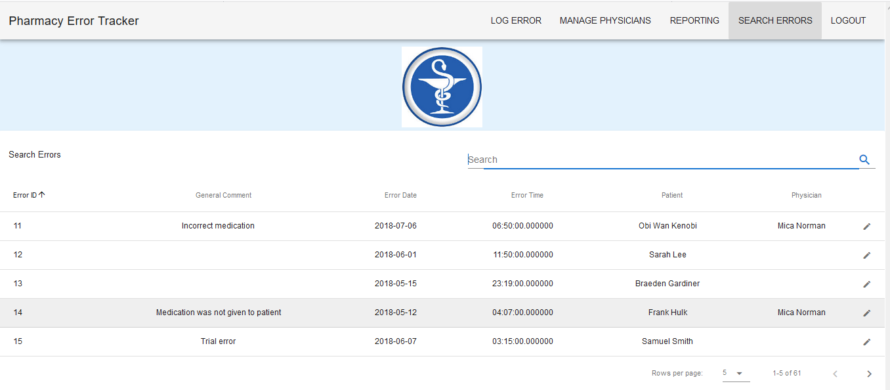

61 records

Error form returned:

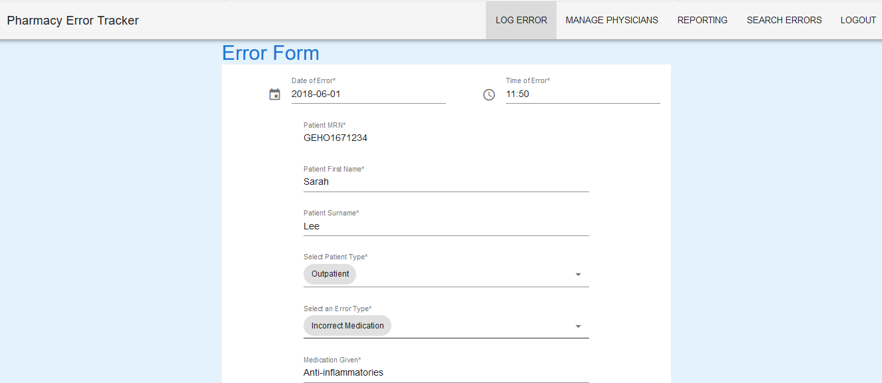

Error details update:

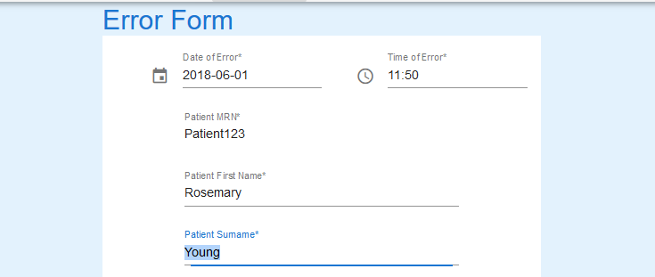

Recorded submitted



Data before Update Data after Update

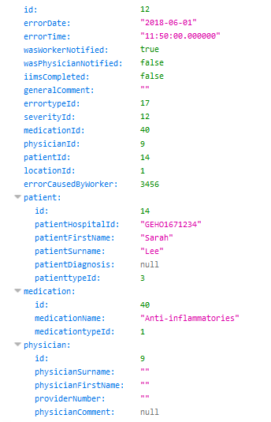 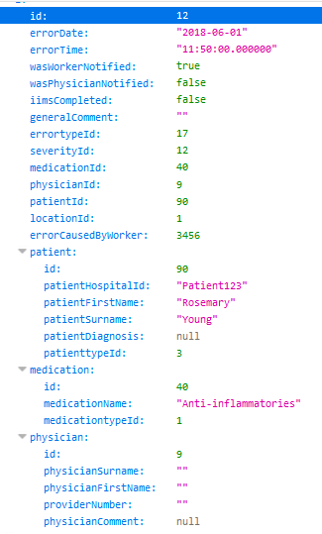

Search after update

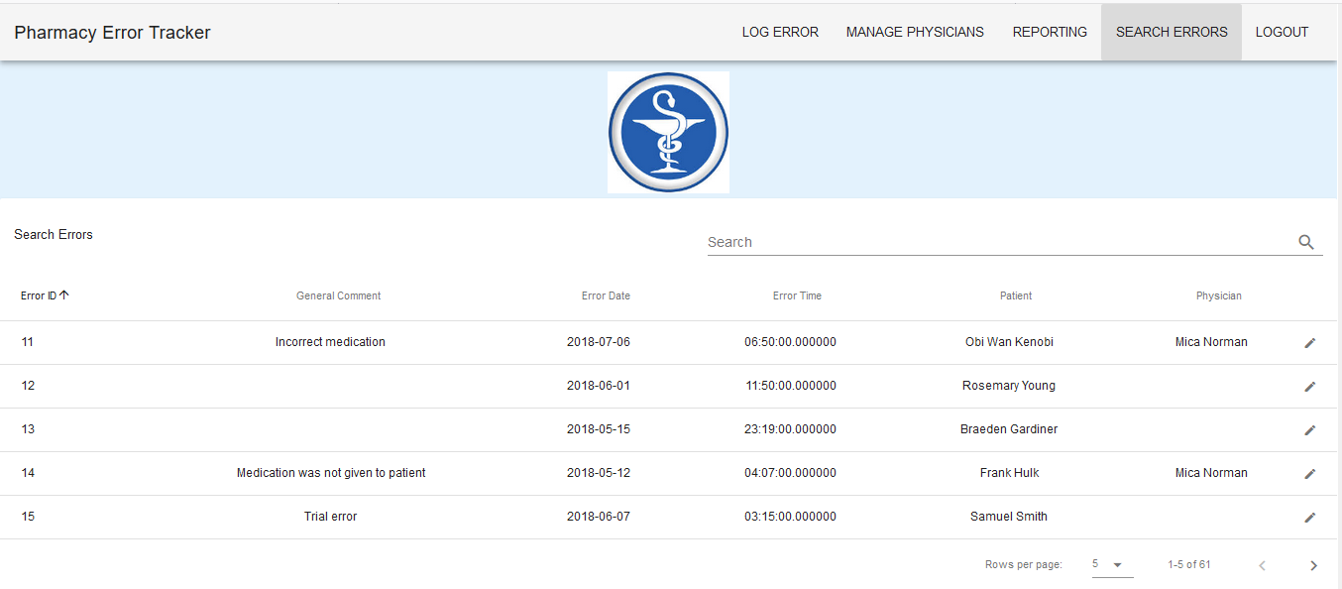

61 records

Server details:

